Table of Contents
List of figures 1
List of tables 2
List of equations 2
1. Anomalous temperature and intentional and unintentional injury mortality in the United States 3
Overview 3
Introduction 4
Data 4
Death rates 4
Anomalous temperature 5
Statistical methods 9
Results 10
Discussion 15
References 24

List of figures
Figure 1. Number of cardiorespiratory deaths deaths, by type of cardiovascular (ischaemic heart disease and cerebrovascular disease) and (COPD and respiratory infections) disease, by sex and age group in the contiguous United States for 1980-2016. 6
Figure 2. National male age-standardised death rates from 1980 to 2016, by cardiorespiratory disease and month 7
Figure 3. National female age-standardised death rates from 1980 to 2016, by cardiorespiratory disease and month 8
Figure 3. Percent change in death rates in year in which each month was +1°C compared with 1980-2009 norm temperatures by type of injury, sex and age group summarised across months. 12
Figure 4. Percent change in death rates in year in which each month was +1°C compared with 1980-2009 norm temperatures by type of injury, sex and month summarised across ages. 13
Figure 5. Additional annual injury deaths for the 2016 US population in year in which each month was +1°C compared with 1980-2009 norm temperatures. The top row shows breakdown by type of injury, sex and age group. The bottom row shows the break down by type of injury, sex and month. Black dots represent net changes in deaths for each set of bars. 14
Figure 6. Percent change in transport death rates in year in which each month was +1°C compared with 1980-2009 norm temperatures by month, sex and age group. 18
Figure 7. Percent change in falls death rates in year in which each month was +1°C compared with 1980-2009 norm temperatures by month, sex and age group. 19
Figure 8. Percent change in drowning death rates in year in which each month was +1°C compared with 1980-2009 norm temperatures by month, sex and age group. 20
Figure 9. Percent change in assault death rates in year in which each month was +1°C compared with 1980-2009 norm temperatures by month, sex and age group. 21
Figure 10. Percent change in suicide death rates in year in which each month was +1°C compared with 1980-2009 norm temperatures by month, sex and age group. 22
Figure 11. Percent change in other unintentional injury death rates in year in which each month was +1°C compared with 1980-2009 norm temperatures by month, sex and age group. 23

List of tables
No table of figures entries found.

List of equations
No table of figures entries found.

1. Anomalous temperature and chronic disease mortality in the United States

Overview
[[[WORDS]]]

Introduction
[[[WORDS]]]

Data

Death rates
I used vital registration data on all injury deaths in the contiguous United States from 1980 to 2016, with information on sex, age at death, underlying cause of death and state of residence. Full details of the method I developed to generate the data can be found in Chapter XX.
During 1980-2016, 4,006,454 boys and men and 1,757,862 girls and women died from an injury in the contiguous United States (i.e., excluding Alaska and Hawaii), accounting for 9.2% and 4.2% of all male and female deaths respectively. 95.6% of male injury deaths and 93.9% of female injury deaths were in those aged 15 years and older, and over half (52.6%) of male injury deaths were in those aged 15-44 years (Figure 1). In contrast with males, there was less of an age gradient in females after 15 years of age.
Injuries from transport, falls, drownings, assault, and suicide accounted for 79.0% of injury deaths in males and 72.1% in females. The remainder were from a heterogeneous group of “other unintentional injuries” (Figure 1), within which the type of injury that led to death varied by sex and age group. Transport was the leading injury cause of death in women younger than 75 years and men younger than 35 years. Between 35 and 74 years of age, more men died of suicide than any other injury. Above 75 years of age, falls were the largest cause of death in both men and women.
There was a decline in age-standardised death rates of three out of five major injuries (transport, drownings and assault) from 1980 to 2016, although assault deaths have shown a recent increase since 2014 (Figure 2). In contrast, age-standardised death rates from falls increased over time while those from suicide initially decreased followed by an increase to surpass 1980 levels. The largest overall decline over time was for transport deaths, which declined by over 50% from 1980 to 2016. Age-standardised death rates for transport injuries and drownings peaked in summer months but deaths from other major injuries did not have clear seasonal patterns.

Anomalous temperature
I obtained data on temperature from ERA-Interim, which combines predictions from a physical model with in-situ and satellite measurements (Dee et al., 2011). I used gridded four-times-daily estimates at a resolution of 80 km to generate monthly population-weighted temperature by state throughout the analysis period. Full details of the method I developed to generate the data can be found in Chapter XX.

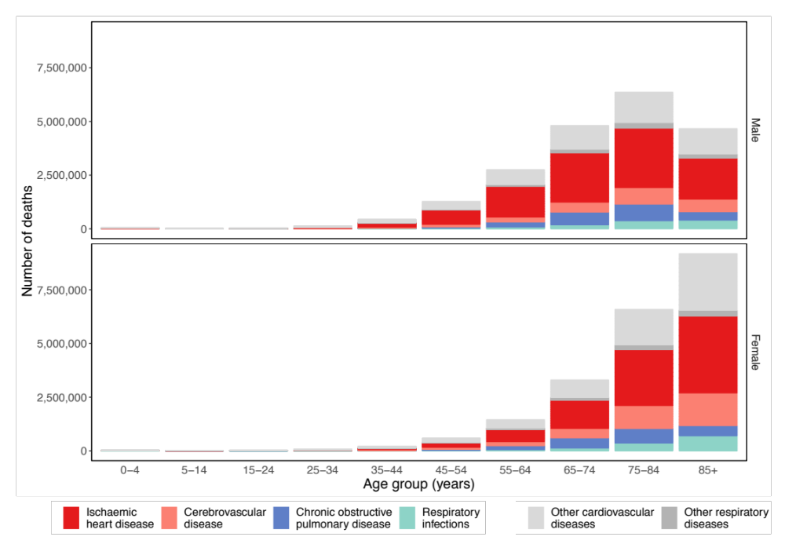
Figure 1. Number of cardiorespiratory deaths deaths, by type of cardiovascular (ischaemic heart disease and cerebrovascular disease) and (COPD and respiratory infections) disease, by sex and age group in the contiguous United States for 1980-2016.
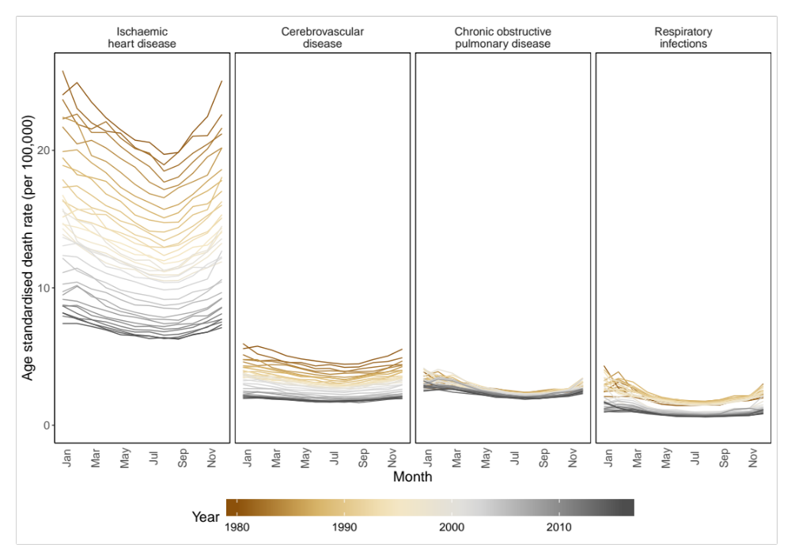
Figure 2. National male age-standardised death rates from 1980 to 2016, by cardiorespiratory disease and month
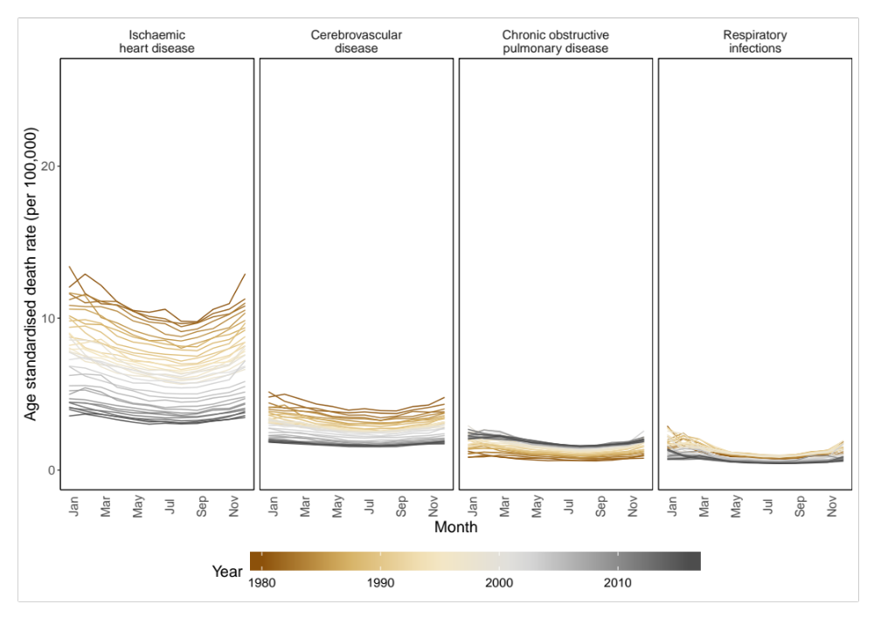
Figure 3. National female age-standardised death rates from 1980 to 2016, by cardiorespiratory disease and month

Statistical methods

National temperature model
I then analysed the association of monthly cardiorespiratory death rates with anomalous temperature using a Bayesian spatio-temporal model, described in Chapter XX. The model accounted for systematic variations in death rates across states and months, through state-, month- and state-month-specific random intercepts, and for their long-term trends. These terms together remove the effects of space and time varying factors other than temperature that affect injuries. Analyses were done separately by injury type, sex and age group. I used the resultant risk estimates and the age-sex-specific death rates from each injury in 2016, to calculate additional deaths if each month in each state were +1°C above its long-term norm, by type of injury, sex, age group, state and month.

Subnational temperature model
I also attempted to run a model where each state was given a separate temperature anomaly coefficient (Equation XX in Chapter XX). However, the model would either not converge or not achieve sensible results and are therefore not shown here.

Results

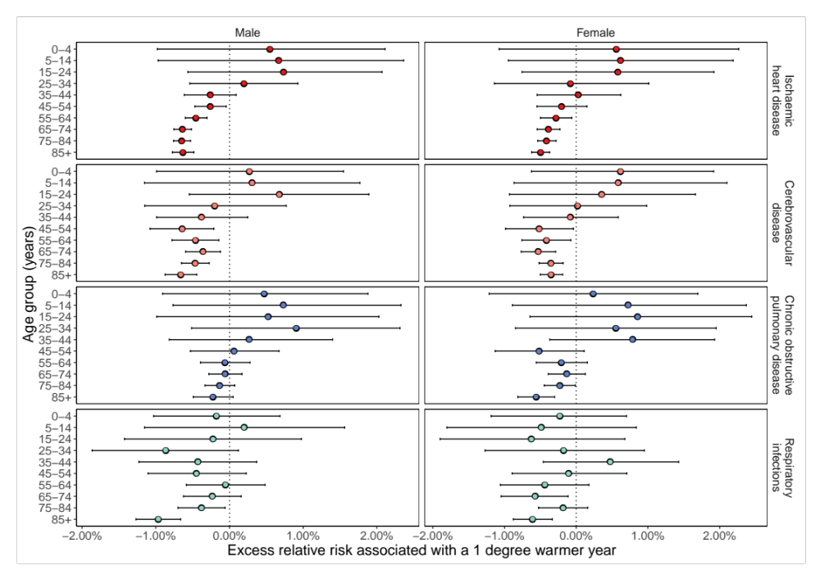
Figure 3. Percent change in death rates in year in which each month was +1°C compared with 1980-2009 norm temperatures by cardiorespiratory disease, sex and age group summarised across months.

Figure 4. Percent change in death rates in year in which each month was +1°C compared with 1980-2009 norm temperatures by cardiorespiratory disease, sex and month summarised across age.

Figure 5. Additional annual cardiorespiratory disease deaths for the 2016 US population in year in which each month was +1°C compared with 1980-2009 norm temperatures. The top row shows breakdown by type of injury, sex and age group. The bottom row shows the break down by cardiorespiratory disease, sex and month. Black dots represent net changes in deaths for each set of bars.

Discussion

[[[Words]]]

Figure 6. Percent change in ischaemic heart disease death rates in year in which each month was +1°C compared with 1980-2009 norm temperatures by month, sex and age group.

Figure 7. Percent change in cerebrovascular disease death rates in year in which each month was +1°C compared with 1980-2009 norm temperatures by month, sex and age group.

Figure 8. Percent change in COPD death rates in year in which each month was +1°C compared with 1980-2009 norm temperatures by month, sex and age group.

Figure 9. Percent change in respiratory infection death rates in year in which each month was +1°C compared with 1980-2009 norm temperatures by month, sex and age group.

Figure 10. Percent change in other cardiovascular disease death rates in year in which each month was +1°C compared with 1980-2009 norm temperatures by month, sex and age group.

Figure 11. Percent change in other respiratory disease injury death rates in year in which each month was +1°C compared with 1980-2009 norm temperatures by month, sex and age group.

References
Burke, M., González, F., Baylis, P., Heft-Neal, S., Baysan, C., Basu, S., & Hsiang, S. (2018). Higher temperatures increase suicide rates in the United States and Mexico. Nature Climate Change. https://doi.org/10.1038/s41558-018-0222-x
Dee, D. P., Uppala, S. M., Simmons, A. J., Berrisford, P., Poli, P., Kobayashi, S., … Vitart, F. (2011). The ERA-Interim reanalysis: configuration and performance of the data assimilation system. Quarterly Journal of the Royal Meteorological Society, 137(656), 553–597. https://doi.org/10.1002/qj.828
Gasparrini, A., Guo, Y., Hashizume, M., Lavigne, E., Zanobetti, A., Schwartz, J., … Armstrong, B. (2015). Mortality risk attributable to high and low ambient temperature: A multicountry observational study. The Lancet, 386(9991), 369–375. https://doi.org/10.1016/S0140-6736(14)62114-0
Gasparrini, A., Guo, Y., Sera, F., Vicedo-Cabrera, A. M., Huber, V., Tong, S., … Armstrong, B. (2017). Projections of temperature-related excess mortality under climate change scenarios. The Lancet Planetary Health. https://doi.org/10.1016/S2542-5196(17)30156-0
Haines, A., & Ebi, K. (2019). The imperative for climate action to protect health. New England Journal of Medicine, (380), 263–273.
Huang, C., Barnett, A. G., Wang, X., Vaneckova, P., Fitzgerald, G., & Tong, S. (2011). Projecting future heat-related mortality under climate change scenarios: A systematic review. Environmental Health Perspectives. https://doi.org/10.1289/ehp.1103456
McMichael, A. J., Woodruff, R. E., & Hales, S. (2006). Climate change and human health: Present and future risks. Lancet. https://doi.org/10.1016/S0140-6736(06)68079-3
Orru, H., & Åström, D. O. (2017). Increases in external cause mortality due to high and low temperatures: evidence from northeastern Europe. International Journal of Biometeorology. https://doi.org/10.1007/s00484-016-1270-4
Parks, R. M., Bennett, J. E., Foreman, K. J., Toumi, R., & Ezzati, M. (2018). National and regional seasonal dynamics of all-cause and cause-specific mortality in the USA from 1980 to 2016. ELife, 7. https://doi.org/10.7554/eLife.35500
Rau, R. (2004). Seasonality in human mortality. A demographic approach. Wirtschafts- Und Sozialwissenschaftlichen Fakultät, PhD, 361. https://doi.org/10.1007/978-3-540-44902-7
Rey, G., Jougla, E., Fouillet, A., Pavillon, G., Bessemoulin, P., Frayssinet, P., … Hémon, D. (2007). The impact of major heat waves on all-cause and cause-specific mortality in France from 1971 to 2003. International Archives of Occupational and Environmental Health. https://doi.org/10.1007/s00420-007-0173-4
Smith, K. R., Woodward, A., Campbell-Lendrum, D., Chadee, D. D., Honda, Y., Liu, Q., … Rocklov, J. (2015). Human health: Impacts, adaptation, and co-benefits. In Climate Change 2014 Impacts, Adaptation and Vulnerability: Part A: Global and Sectoral Aspects. https://doi.org/10.1017/CBO9781107415379.016
Watts, N., Amann, M., Arnell, N., Ayeb-karlsson, S., Belesova, K., Lucien, P., … Grace, D. (2018). The 2018 report of the Lancet Countdown on health and climate change: shaping health of nations for centuries to come. The Lancet, 6736(18), 1–4. https://doi.org/10.1016/S0140-6736(18)32594-7

